**COMPANY PROFILE**

1. **Our Mission**

PADRÃOS mission is assist Clients and Community in achieving the highest SHE standards to promote health, safety and environment care.

1. **Our Vision**

Is to make PADRÃO the Company of choice when it comes to health Safety and Environment management and to promote the Zero Harm dream together with the Client and the Community.

1. **Our Values**

At PADRÃO :

We are responsible, accountable, respectful, effective, efficient public stewards,

We promote honesty, integrity and openness in all we do,

We encourage innovation to meet challenges,

We foster an environment of collaboration.

1. **PADRÃO Consultoria & Serviços**

Padrão is a consulting company, registered in Inhassoro-Inhambane owned by a Mozambican citizen, operating in the occupational, health and safety field, with a competent team which has completed various projects in Mozambique, from the tender phase, execution, audit and other areas of operation such as:

* SHE File Elaboration And Implementation,
* Occupational Health And Safety Trainings,
* Training And Supply Of SHE Personnel (SHE Officers, SHE Reps),
* High Quality Safety Signs For Roads, Projects (Banner, Vinyl, Metallic, Reflective…)
* Embroidery And Printing On Clothing and PPE,
* Supply Of Personal Protective Equipment,

1. **Managing Director CV**

Padrão´s Managing Director has a large experience in the construction safety field, with more than 12 years experience Managing SHEQ in Construction sites, Breweries and live gas plants with the following responsibilities:

* Provide proactive support to external customers, for working sites and offices,
* Monitoring and preventing potential workplace safety hazards through routine inspections and trainings,
* Update policies, procedures, investigations into accidents/incidents and non-conformities,
* Compile SHE files, participating in tenders, budgeting SHE consumables, equipment and materials,
* Introduction and implementation of international standards for OH´S (ISO 45001), Environment (ISO 14001) and Quality (ISO 9001).

1. **PPE Supply**

|  |  |  |
| --- | --- | --- |
| 1. Reflective Vests | 1. Hearing Protection | 1. Footwear |
| 1. Welding, Grinding rotection | 1. Protective Eyewear | 1. Protective Clothing |
| 1. Spill Kits, Breathalyzer | 1. Rainwear | 1. Hand Protection |

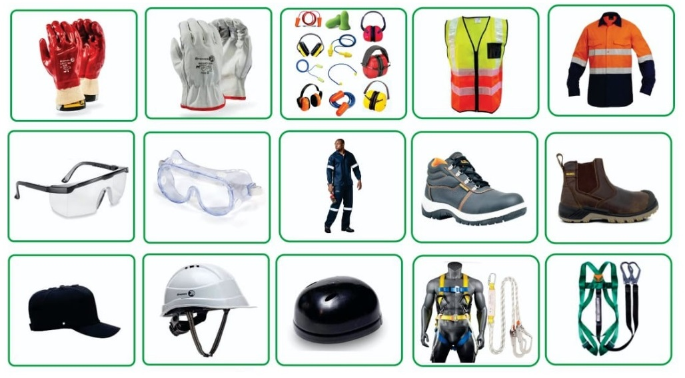

1. **Company Organogram**
2. **Clients & Partners**

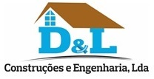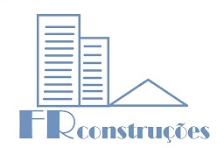

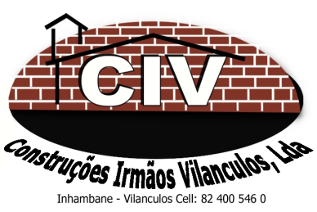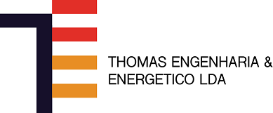 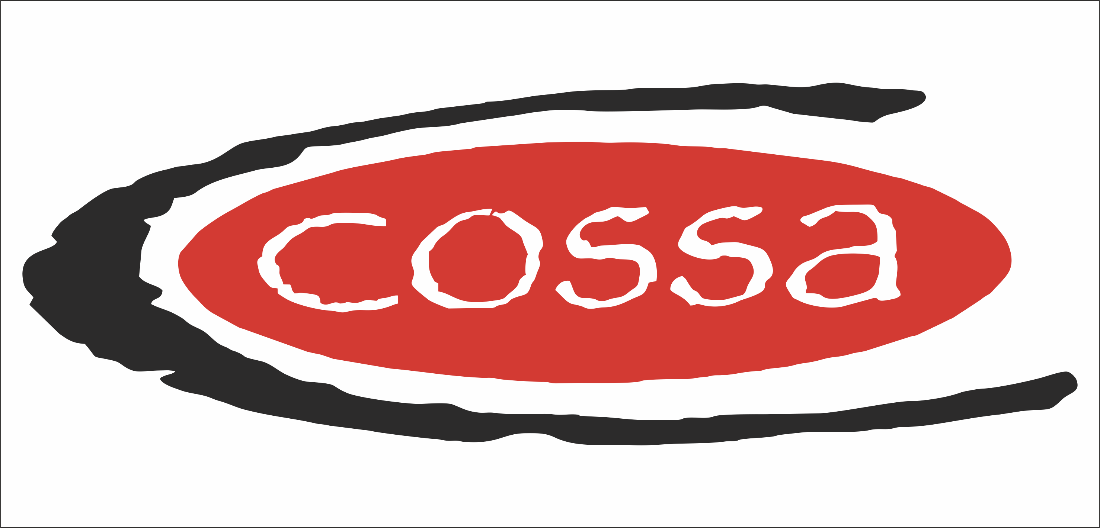

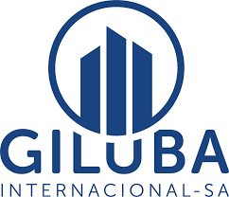 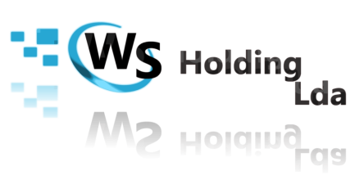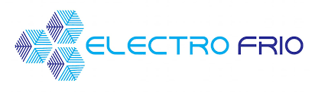

1. **Conclusion**

Padrão is committed to a high standard Occupational Health and Safety Management System implementation, from the interpretation of the Mozambican labour law and international best standards and conform to the applicable legislation, Padrão supply high quality PPE, supporting the most commendable brands to ensure compliance and effectiveness.